Course Four

Regression Analysis: Simplifying Complex Data Relationships
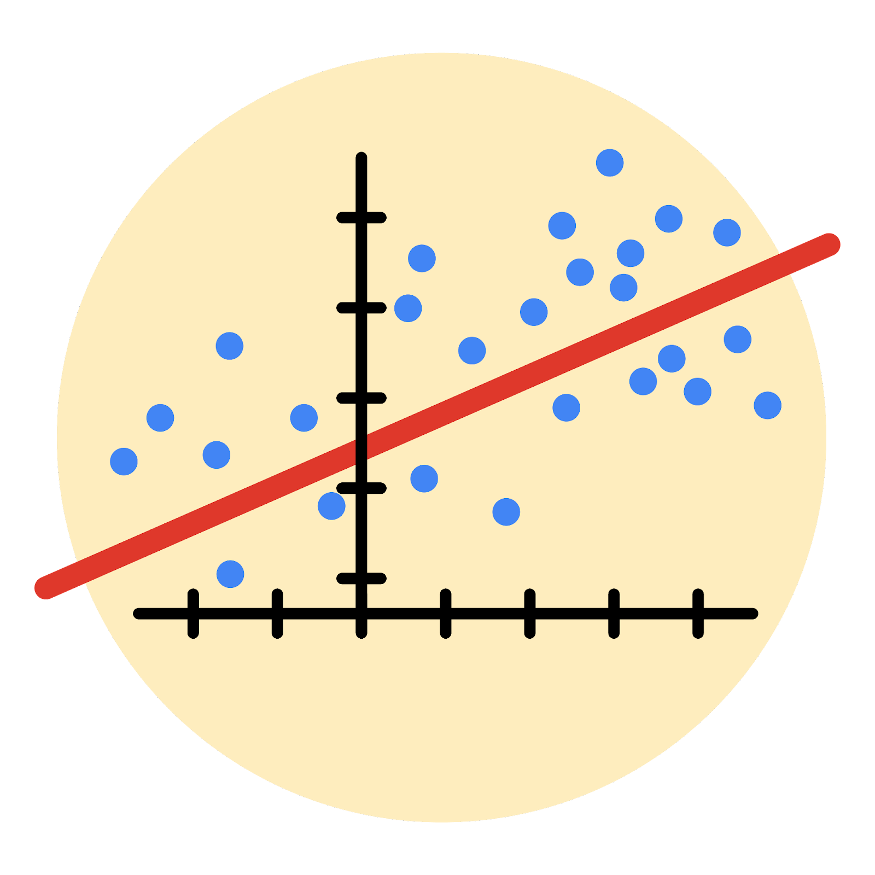

Instructions
Use this PACE strategy document to record decisions and reflections as you work through this end-of-course project. As a reminder, this document is a resource that you can reference in the future, and a guide to help you consider responses and reflections posed at various points throughout projects.

Course Project Recap
Regardless of which track you have chosen to complete, your goals for this project are:
- Complete the questions in the Course 4 PACE strategy document
- Answer the questions in the Jupyter notebook project file
- Build a multiple linear regression model
- Evaluate the model
- Create an executive summary for team members

Relevant Interview Questions
Completing the end-of-course project will empower you to respond to the following interview topics:
- Describe the steps you would take to run a regression-based analysis
- List and describe the critical assumptions of linear regression
- What is the primary difference between R² and adjusted R²?
- How do you interpret a Q-Q plot in a linear regression model?
- What is the bias-variance tradeoff? How does it relate to building a multiple linear regression model? Consider variable selection and adjusted R².
Reference Guide
This project has seven tasks; the visual below identifies how the stages of PACE are incorporated across those tasks.
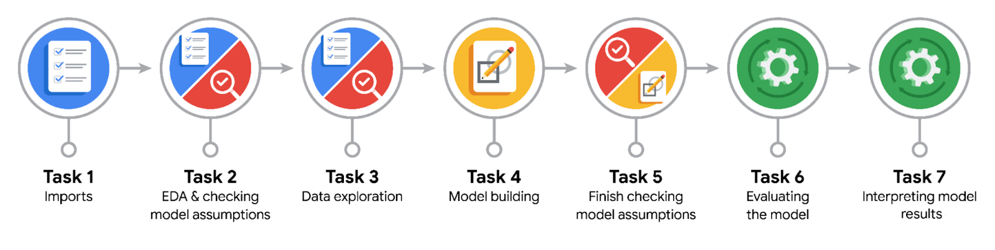

Data Project Questions & Considerations
PACE: Plan Stage
- Who are your external stakeholders for this project?
The external stakeholders for this project are the NYC Taxi and Limousine Commission (TLC).

- What are you trying to solve or accomplish?
We want to build a multiple linear regression model to predict taxi fares based on the data collected by the NYC TLC.

- What are your initial observations when you explore the data?
The dataset contains 22699 entries with 18 columns. The first column contains an id, while the other columns contain various information about the taxi rides.
There is a mix of data types (int, float, and strings).
The data contains no missing values.

- What resources do you find yourself using as you complete this stage?
Various methods contained in Pandas.

PACE: Analyze Stage
- What are some purposes of EDA before constructing a multiple linear regression model?
Some purposes of EDA before constructing a multiple linear regression model are the following:
- Understand what variables are contained in the dataset and what they represent
- Understand what data type each variable has, and how the values are distributed (e.g. min, mean, and max for continuous variables, frequency distribution for categorical variables)
- Determine whether there are missing values, invalid data, or outliers
- Analyse the relationship between the different variables

The last step will help us make assumptions about the model we could use.

- Do you have any ethical considerations at this stage?
The main ethical consideration at this stage concerns how missing values and outliers are handled. Great care should be taken when considering removing or imputing values, as these operations might introduce bias in the data and result in a model that misrepresents reality.

PACE: Construct Stage
- Do you notice anything odd?
Regarding the variables that were created in the previous stage, mean_duration, and mean_distance, there were some cases where the values were zero or even negative. These data points were imputed before proceeding to the construct stage.

- Can you improve it? Is there anything you would change about the model?
We could modify the predicted values to make sure that if the RateCodeID is 2, the predicted fare_amount is set to the same value as in the observed data.
Only the predictors that have a significant influence on the fare_amount could be kept for the final version of the model.

- What resources do you find yourself using as you complete this stage?
The functions from scikit-learn are needed for building and evaluating the model. The seaborn package is very useful for visualizing the results.

PACE: Execute Stage
- What key insights emerged from your model(s)?
With the variables included in the training of the model, we obtained a model whose R-squared value was 0.868, which is relatively high. The visualization of the values predicted by the model versus the actual values further confirmed that the model performs well.
Additionally, the residuals were normally distributed around 0, which shows that the assumption of normality is met. The residuals are also scattered in homogeneous way across the range of predicted values.

- What business recommendations do you propose based on the models built?
The fare_amount can be predicted using the mean_distance and mean_duration of the trips.

- To interpret model results, why is it important to interpret the beta coefficients?
It is important because it enables us to understand how a potential change in amounts of one of the predictor variables can affect the outcome variable. This is what then allows us to predict the outcome variable for a given set of values for the predictor variables.

- What potential recommendations would you make?
Based on the results obtained, the model we built could be used to provide customers with estimated fare_amounts.

- Do you think your model could be improved? Why or why not? How?
The model could be improved by taking into account the RateCodeID (or, alternatively, consider whether the pick-up or drop-off locations are the JFK airport). It could also be simplified to keep only the mean_distance, as it is highly correlated with the duration.
We could also potentially investigate the relationship of the pair of pick-up and drop-off locations on the fare_amount instead of using the mean_duration and mean_distance.
- What business/organizational recommendations would you propose based on the models built?
To predict the fare amount, we can use the pick-up and drop-off locations indicated by the customer. We can also potentially add an adjustment depending on whether the trip is occurring during rush hour.

- Given what you know about the data and the models you were using, what other questions could you address for the team?

- Do you have any ethical considerations at this stage?
When communicating the results to stakeholders, it is important to state what assumptions we made, how we may have transformed some data used for the training of the models, and what are data we might have intentionally left out. For the model itself, providing the p-values and confidence intervals for each coefficient would be good practice.

